Phase I and Phase II Results – California (CA)

A. Plots of Predictors vs. HPI (simple returns)

Original HPI Series
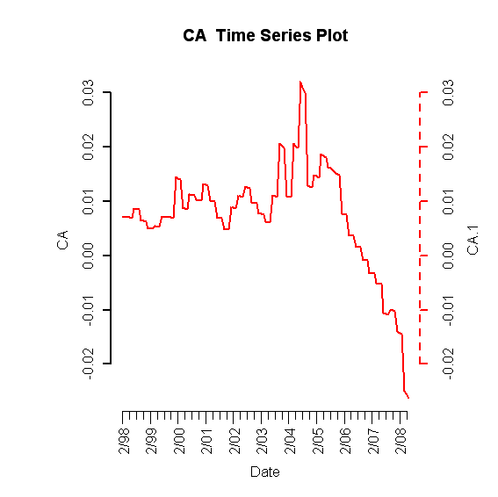

Building Permits
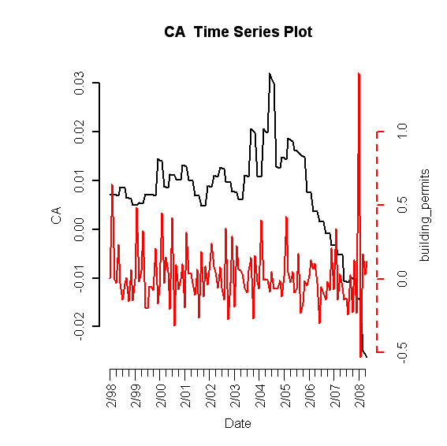
Foreclosures
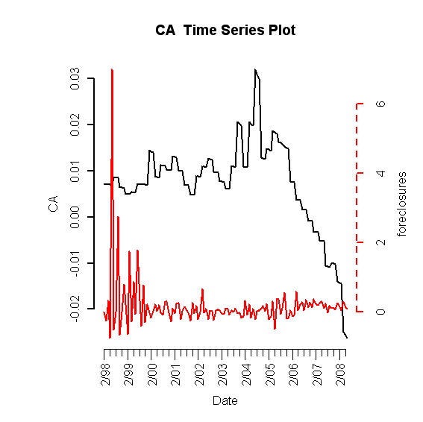

Population Size
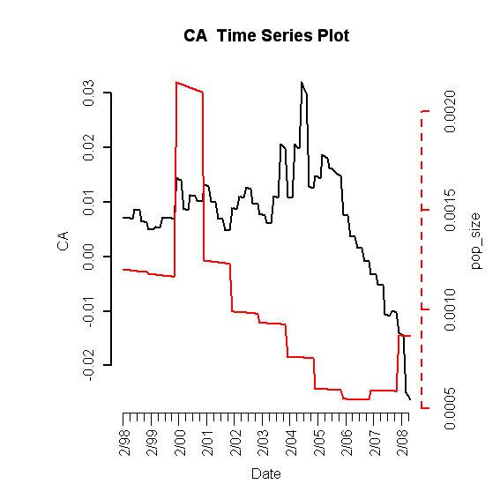
Unemployment Rate
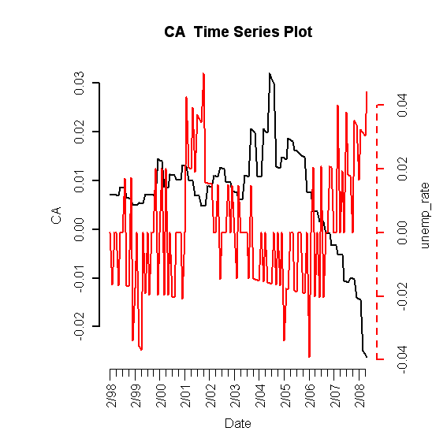
Mortgage Originations

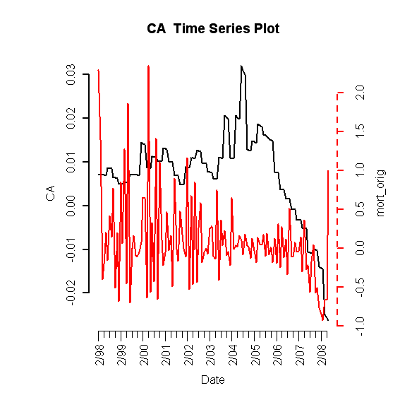

30-Year Commitment Rate
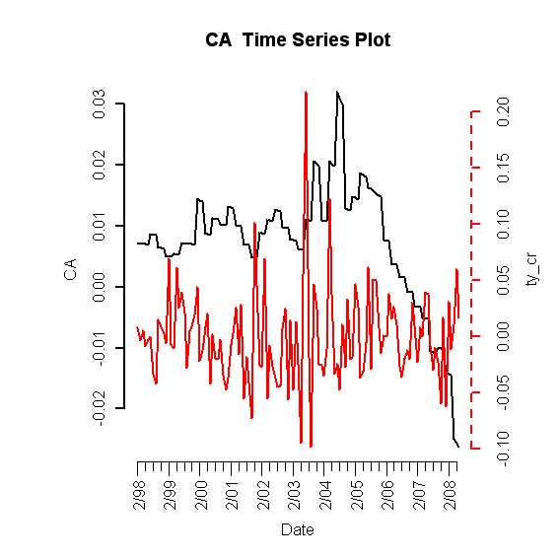
Median Income
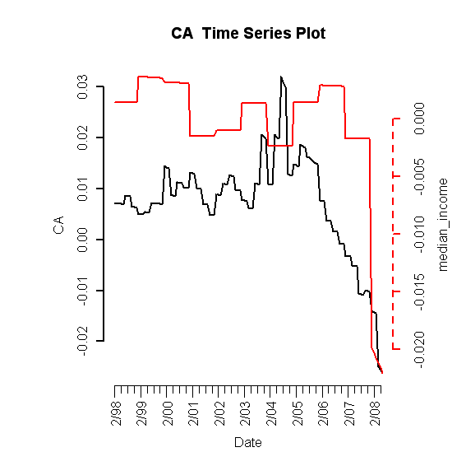

B. Plot of Lagged Predictors vs. HPI (simple returns)

Median Income (lagging 15 months)
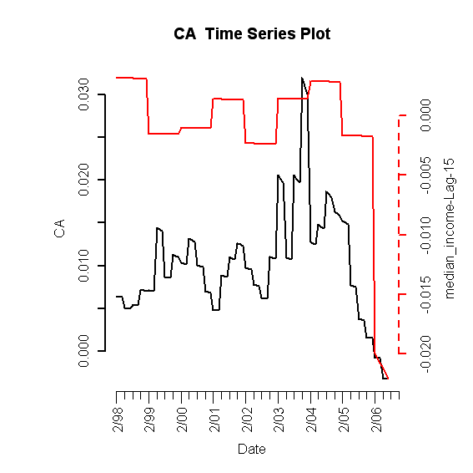

Unemployment Rate (leading 1 month)
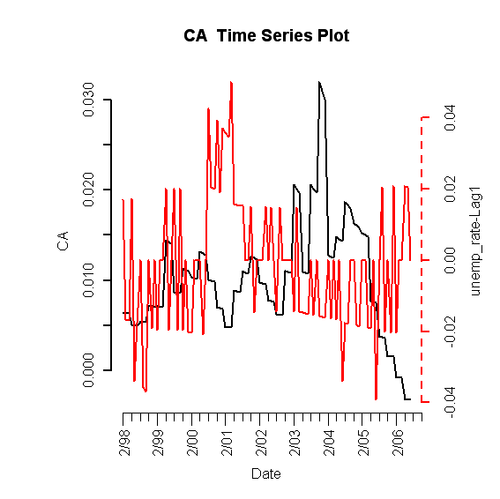

Population Size (leading 8 months)
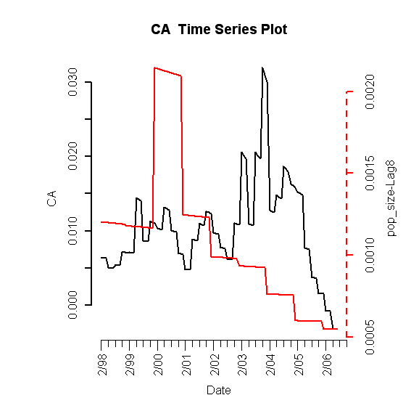
C. Scatterplots (simple return)

HPI vs. HPI
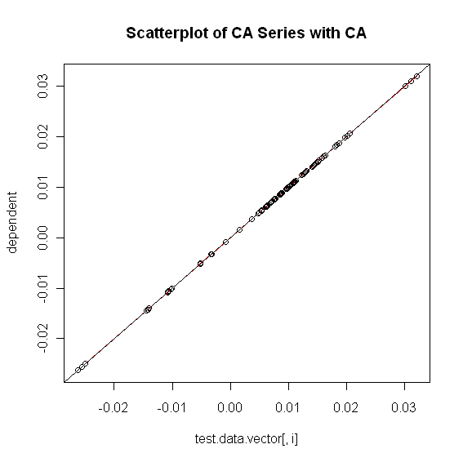

HPI vs. Building Permits
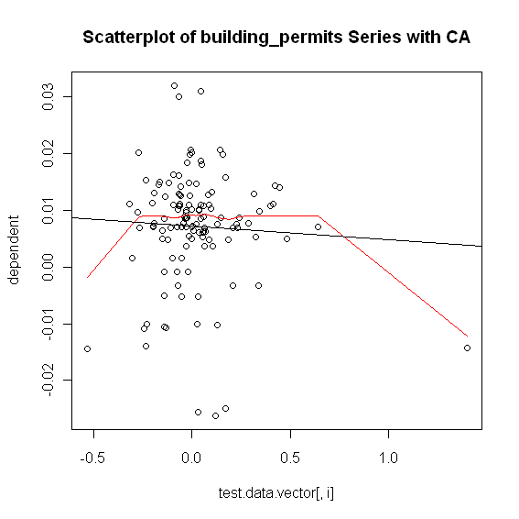

HPI vs. Foreclosures
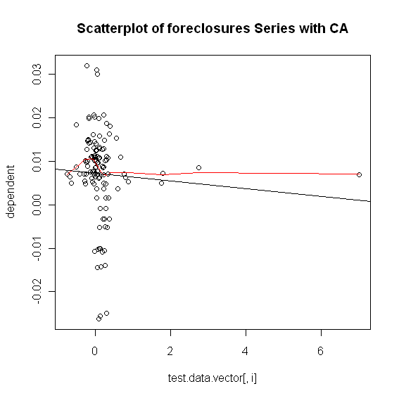
HPI vs. Population Size
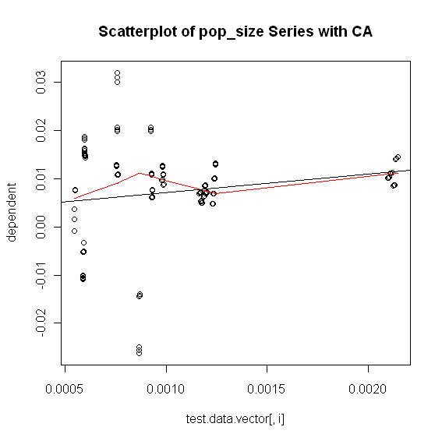

HPI vs. Unemployment Rate
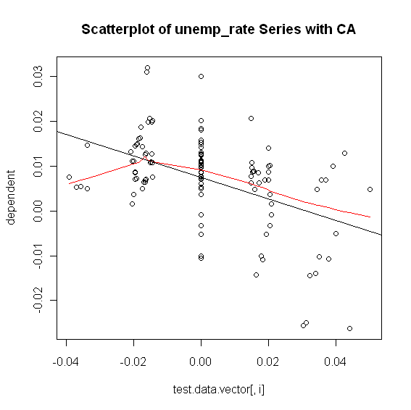

HPI vs. Mortgage Originations
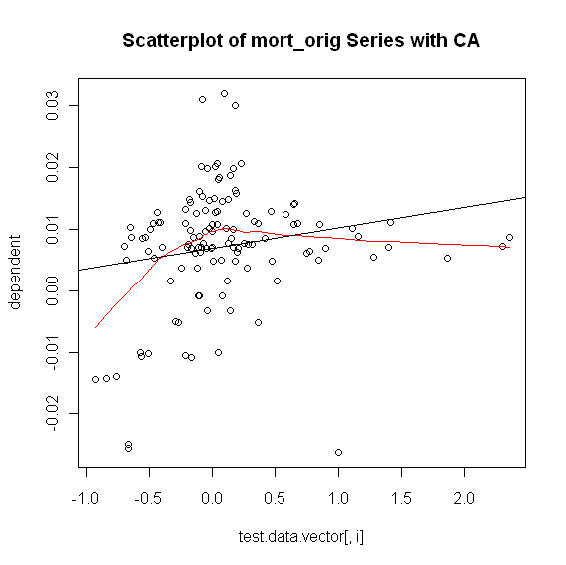

HPI vs. 30-Year Commitment Rate
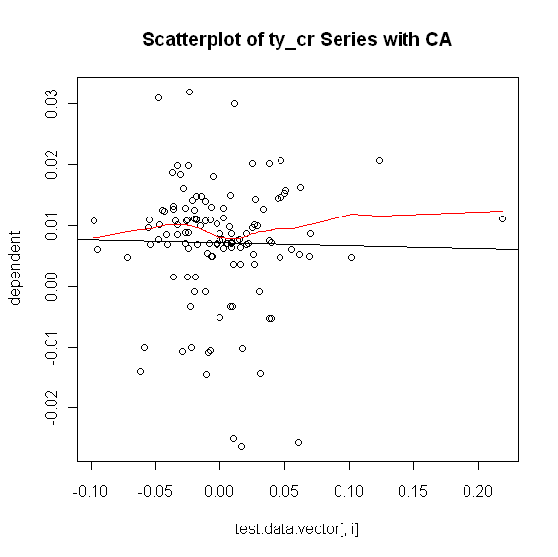

HPI vs. Median Income
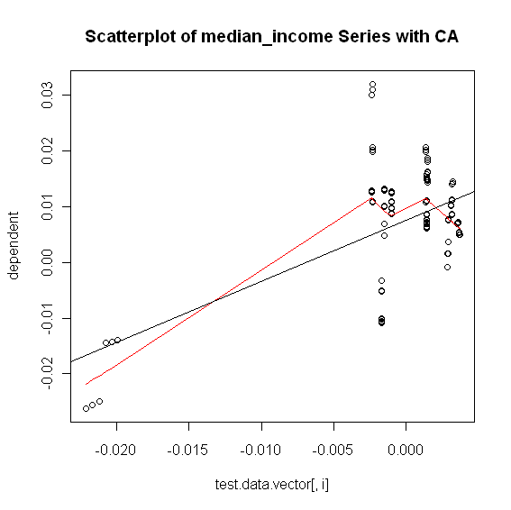
C. Exhaustive Stepwise Regression
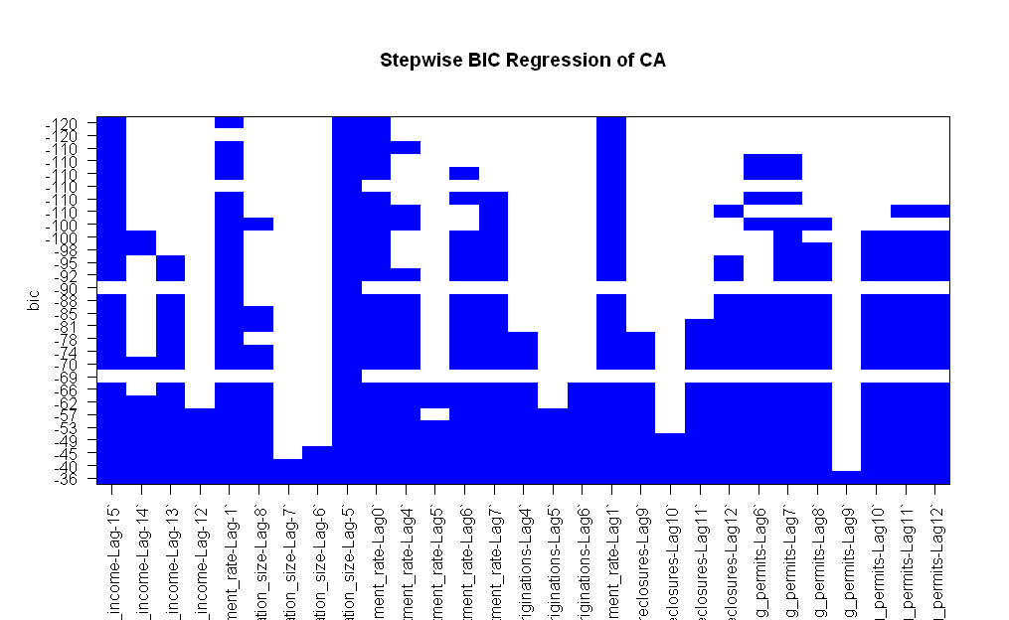

D. Final RLM Model

Robust Linear Model (significant predictors only)

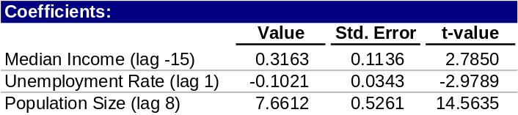

Robust Linear Model (one of each predictor)

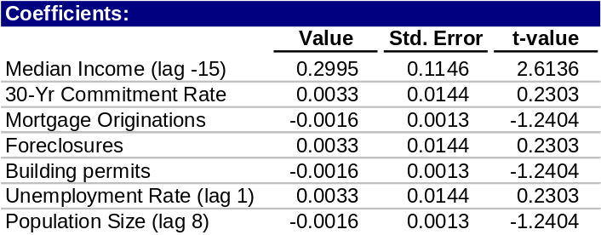

Fitted HPI vs. Actual HPI (without Phase II modeling)
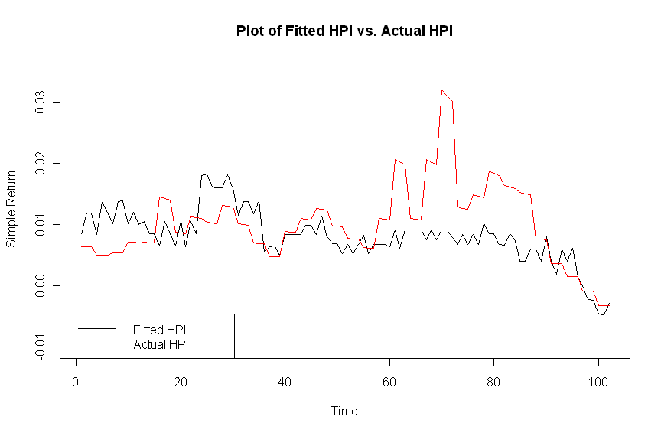
Fitted HPI vs. Actual HPI (with Phase II modeling)
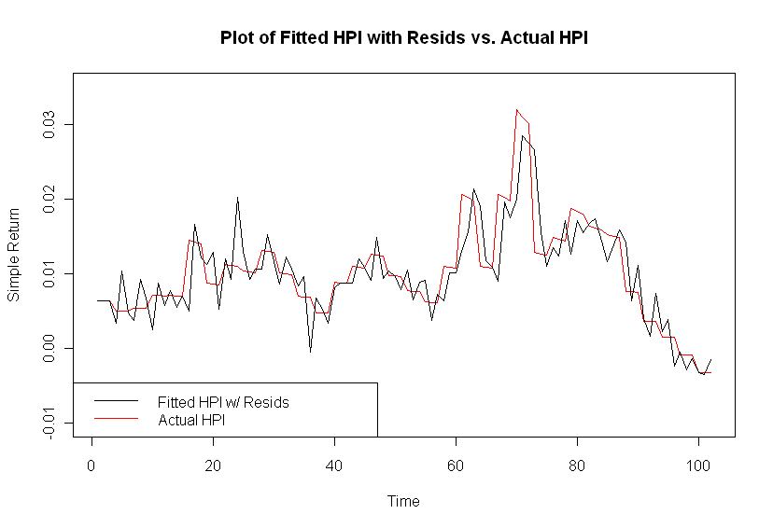

1. Phase I

ACF of Residuals
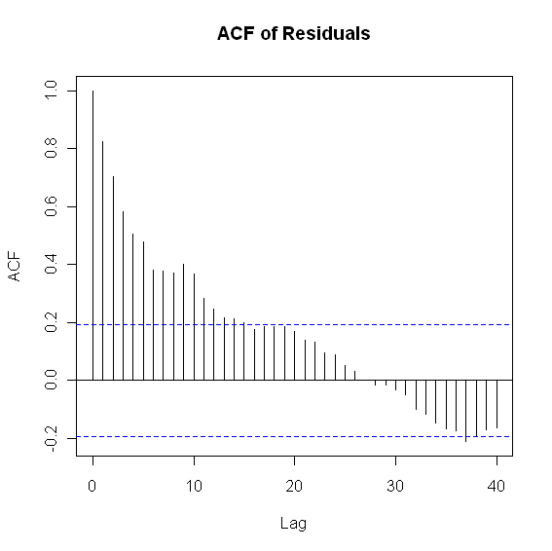
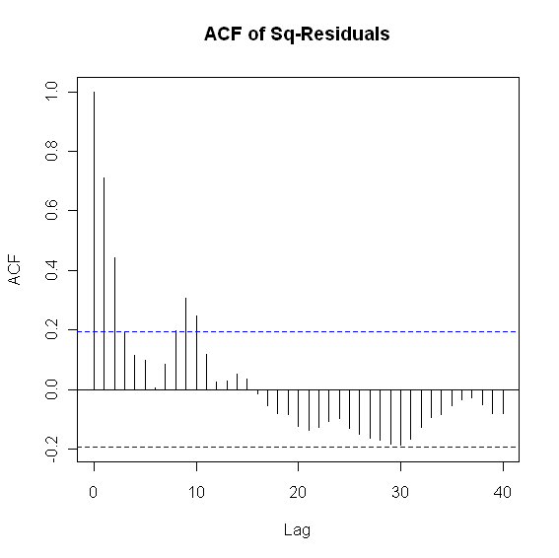

PACF and ADF Test
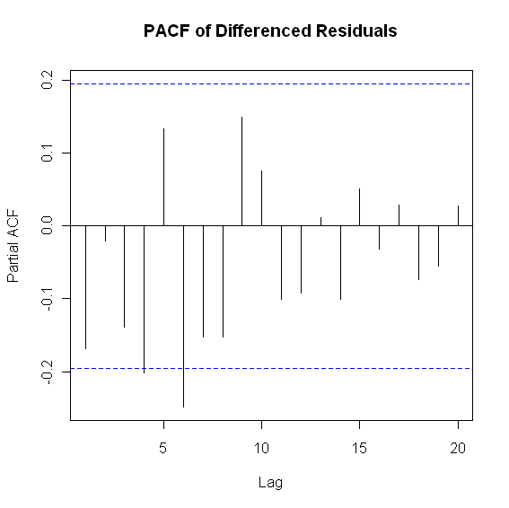
The value of the test statistic is: -1.6321
> ur.df(y$residuals,lags=7,type="none")@cval
1pct 5pct 10pct
tau1 -2.58 -1.95 -1.62

Box-Ljung Test

> Box.test(y$residuals, lag = 12, type = c("Ljung-Box"))
Box-Ljung test
data: y$residuals
X-squared = 310.6564, df = 12, p-value < 2.2e-16

2. Phase II

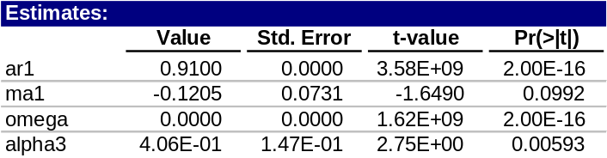

Box-Ljung Test

> Box.Ljung.test(sresi, lag = 12, adj.DF = 12-meanParams)
data: data
X-squared = 16.341, df = 10, p-value = 0.09028

> Box.Ljung.test(sresi^2, lag = 12, adj.DF = 12-volParams )
data: data
X-squared = 13.9197, df = 8, p-value = 0.08388

Phase I and Phase II Results – Idaho (ID)

Phase I and Phase II Results – Florida (FL)

